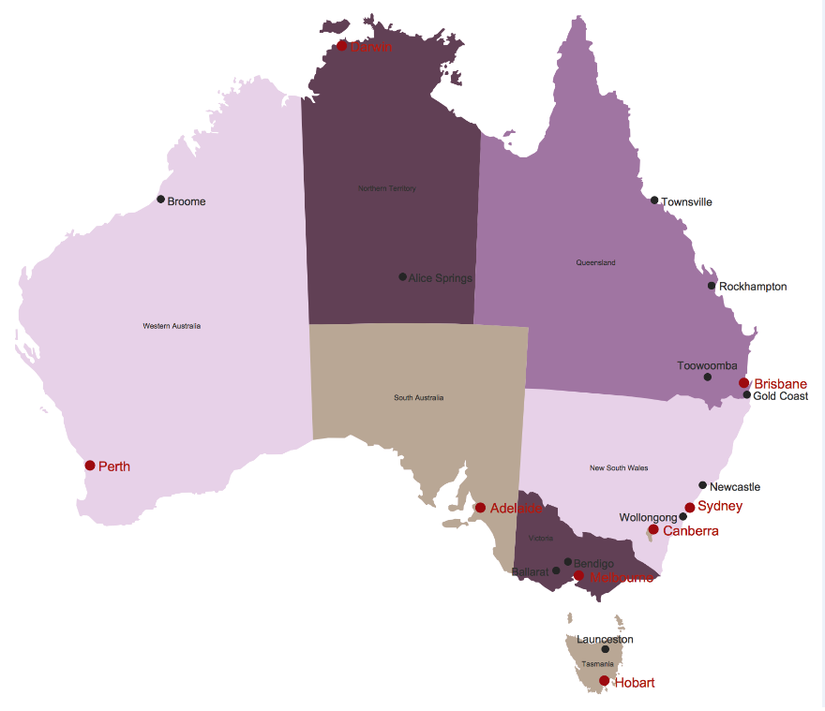

|  |
| --- |
| Individual Assignment  Analysing and Visualising Australian Election database  **This report has been prepared by:**  **Pranitha Gaddam 221183244** |
| MIS781 Business Intelligence and Database Practical Assignment |

Contents

**1. Introduction** 2

**1.1 Objectives of your BI Dashboards** 3

**1.2 Benefits/Advantages of your BI Dashboards** 4

**1.3 Assumptions** 4

**1.4 Description of business rules and of variables used in this report** 4

***2.1 Dashboard 1: For AEC*** 6

Chart 1- 7

Chart 2 8

Chart 3 – 9

Chart 4 - 10

***2.2 Dashboard 2: For Political Parties*** 11

Chart 1 12

Chart 2 – 13

Chart 3 – 14

Chart 4 – 14

Chart 5 – 15

***2.3 Dashboard 3: For the Public*** 16

Chart 1 – 17

Chart 2 - 18

Chart 3 - 19

Chart 4 – 20

**4. Reference (APA ref)** 26

**Table of Figures**

Figure 1Dashboard for the AEC 7

Figure 2Total Percentage and Provisional Votes by Party Name and State 8

Figure 3 Ordinary Votes and Total Votes by State 9

Figure 4 Postal Votes, Absent Votes and Declaration Pre-poll Votes by Party Name. 10

Figure 5 Elected and Nominated candidates by Party Name 11

Figure 6 Dashboard for the Political Parties 12

Figure 7 Average of Polling Place ID by Polling Place and Party Name 13

Figure 8 Table showing Division Name, Given Name, Elected and Historically Elected 14

Figure 9 Swing rate 14

Figure 10 Swing percentage by Party Name and Party Abbreviation 15

Figure 11 Ordinary Votes by Elected, Party Name and State Abbreviation 16

Figure 12 Dashboard for the Public 17

Figure 13 Table displaying Division Name, State Abbreviation and Premier Name 18

Figure 14 Treemap for Voter Enrolment and Ordinary Votes by Premier Name and State Ab 19

Figure 15 Total Votes and Total Percentage by Premier Name and State Ab 20

Figure 16 Postal Votes by Premier Name 20

# **1. Introduction**

*NB: Please note that the following datasets provided are imported from the AEC website – 2016 General Elections.*

This report discusses findings and insights on the Australian Elections based on the available datasets using the Power BI software. The Australian elections play a pivotal role in Australia’s government and economic sustainability. Nowadays, people are keen to gain a descriptive visualisation of the elections rather than scouring through multiple rows of data. Thus, the election dashboards are created to different stakeholders via key visualisation techniques. Moreover, BI is used specifically to understand trends and derive insights from this dataset.

The first dashboard focuses on the stakeholder **Australian Electoral Commission (AEC)** which conducts federal parliamentary elections and assists with State / Local elections. Since, AEC is a government body, it requires providing information and advice on electoral matters to the parliament and government departments. Additionally, AEC engages in active electoral roll management and efficient delivery of polling services by conducting and promoting further research into electoral matters(aec.gov.au). This dashboard showcases the voter turnout in each state by voter percentage including the percentage of Ordinary Votes, Provisional Votes and Absent Votes by State such as NSW, ACT, NT, etc. Elected and Nominated Premiers are also a key information beneficial to the AEC.

The second dashboard spotlights on **Political Parties** as the stakeholder. The major Australian Political Parties from the dataset include Australian Labour Party, Liberal National Party and The Nationals. These stakeholders are concerned about the swing percentage between each party, the average polling places held across States and whether the candidates in elections have been previously elected or not.

Lastly, the third dashboard is for the **Public** or Media use. People have been interested in election results to determine their economic and financial stability. This dashboard provides rich insights on the total votes and total percentage by States and their respective parties. Since, the Public is more concerned about the election results rather than having an in-depth analysis of election database, this dashboard has a more simplified version of ordinary votes and voter enrolment.

Lastly, using Business Intelligence to analyse the election database provides an enhanced visualisation to the users such as using Power Maps, ArcGIS Maps and other creative functions which are more apt big data analytics. Election databases are generally large in nature as it accounts for the voter population in Millions and thus providing more valuable insights to the government departments and required bodies. Additionally, this plays a role in determining how to best shape the elections in future, whether to increase the online voter system or ease of use electronic ballot system to mitigate the risks of hampering the elections with fake results.

The Key Stakeholders are:

1. AEC
2. Political Parties
3. Public

## **1.1 Objectives of your BI Dashboards**

* To provide the users with a more real-time centralised and dynamic view of the dataset.
* To display an accessible, in-depth, and personalised view of the dashboards in a way that inspires action or accelerates decision-making across the organisation.
* To present a sleek and consolidated visibility by combining data from a variety of systems into a single, summarised, unified view of the election database.

## **1.2 Benefits/Advantages of your BI Dashboards**

* *Benefit 1 -* BI dashboards provide real-time data analytics, with accurate insights based on the election dataset. Real-time insights allow for faster decision-making, more enhanced visualised interactivity with large amounts of data.
* *Benefit 2 -* These are highly customisable in terms of users and expectations – each decision level dashboard can be customised to present the most valuable set of information, allowing each stakeholder to see the level of detail they require ("Business Intelligence Dashboard", 2021).
* *Benefit 3 -* It enhances visibility due to the rich personalised dashboards which present a dynamic, real-world view with timely data updates to ensure faster response to changing market conditions.

## **1.3 Assumptions**

The findings and analyses identified by the dashboard are derived from an amalgamation of publicly available data sources identified in Table x.

**Table 1 Assumptions**

|  |
| --- |
| **Assumption 1:** We assume the names of the Premiers in the Public dataset as the real names. |
| **Assumption 2:** We assume that the swing number showcased is the cumulative percentage figure from the dataset |
| **Assumption 3:** We assume that the ordinary votes are vote casted on election day at a particular polling place within the electoral division. |
| **Assumption 4**: We assume that the Historic Elected implies historically or previously elected in the prior elections. |
| **Assumption 5:** We assume that the Total Votes includes all the ordinary, absent, provisional, pre-poll and postal votes. |

**Table of State Names and Abbreviations that have been mentioned in the report :**

**NSW – New**

**South Wales**

**VIC – Victoria**

**WA – Western Australia**

**SA – South Australia**

**QLD – Queensland**

**ACT – Australian Capital Territory**

**TAS – Tasmania**

**NT – Northern Territory**

## **1.4 Description of business rules and of variables used in this report.**

## 

**Table 2. Business Rules and Final Variables used for analysis.**

|  |  |  |  |
| --- | --- | --- | --- |
| **Value** | **Description** | **Data Type** | **Rules** |
| Party Name | The name of each party in the respective state | String | Must be a string text |
| Total Percentage | The percentage of the votes counted for each party | Float | Must have a decimal place in number |
| Provisional Votes | When the voter’s name is absent as they might not be registered to vote. | Integer | Must be a unique number |
| State Ab | Abbreviation for State | String | Must be a string text.  Must be a unique value |
| Postal Votes | Ballot papers are distributed to electors by post | Integer | Must be a unique number |
| Absent Votes | A polling booth where no electoral roll is held for the electoral district, the voter would then give an absent vote. | Integer | Must be a unique number |
| Declaration Prepoll votes | Vote issued to an elector who is voting in person at an early voting centre. | Integer | Must be a unique number |
| Ordinary Votes | A vote cast on election day wherein the voter is enrolled | Integer | Must be a unique number |
| Total Votes | This number is referring to the number of votes that were counted for the winning party in million | Integer | Must be a unique number |
| Elected | The number of individuals that were successfully elected for seats in the winning party | Integer | Must not be a null value |
| Nominations | The number of individuals that were nominated for seats from the winning party | Integer | Must not be a null value |
| Polling Place ID | The ID for each Polling Place | Integer | Must be a unique value |
| Polling Place | Place where voters cast their ballots | String | Must be a string text |
| Swing (%) | The change in the voter support, expressed in positive or negative percentage. | Float | Value cannot exceed 100% |
| Division Nm | It is an administrative unit/division in each State. | String | Must be a string text |
| Given Nm | The given name of each candidate in the elections | String | Must be a string text |
| Premier Name | The premier that will represent each party in the state election. | String | Must be a string text |
| Historic Elected | Whether the premier has been previously elected | Integer | Must be a string text |
| Enrolment | Voter Enrolment – by law, every citizen must enrol and vote in the elections | Integer | Must be a unique value.  Cannot be a null value |

**2.BI DASHBOARDS**

## ***2.1 Dashboard 1: For AEC***

This dashboard showcases the charts for the Australian Electoral Commission (AEC). The Australian elections held under the jurisdiction announce the winning candidate and the party accordingly. The 4 charts below represent the relationship between the public votes given to each party, therefore, counting towards the maximum seats won by an elected party. The visualisations used below are clustered bar chart, stacked bar chart, treemap and column bar chart, respectively. They focus on the Total Percentage and Provisional Votes by Party Name and State Abbreviation. Moreover, the elected and nominations candidate indicate which candidates are preferred over others even though they have been nominated for the position. This further helps in setting electoral boundaries to maintain the Commonwealth electoral roll regulations and guidelines.

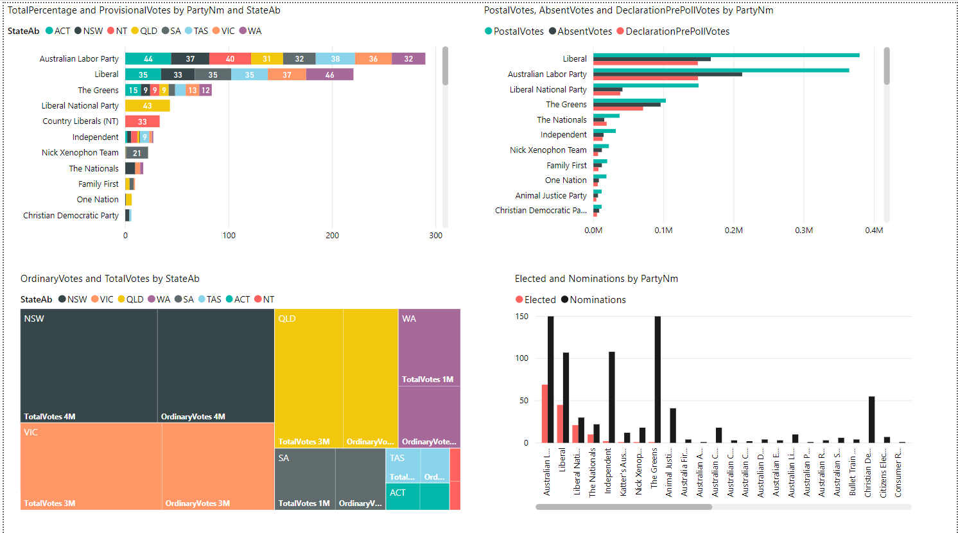

Figure 1Dashboard for the AEC

## Chart 1-

Figure 1 showcases a clustered bar chart having more than one data series in clustered horizontal columns ("Clustered Bar Chart | Exceljet", 2021). The horizontal bars are grouped by category into Party Name and States. Whereas the x-axis has the total percentage of Total Votes. The data collected explains the relationship between the Provisional Votes and total percentage between Party and State. We can see below that Australian Labor Party received the maximum provisional votes of 44% in Australian Capital Territory and 37% in New South Wales, followed by Liberals gaining 35% in ACT and The Greens with over 15% in ACT. Whilst Christian Democratic Party gained the least number of votes in every state. A total of upto 300 provisional votes is the extent to which the votes can be cast.

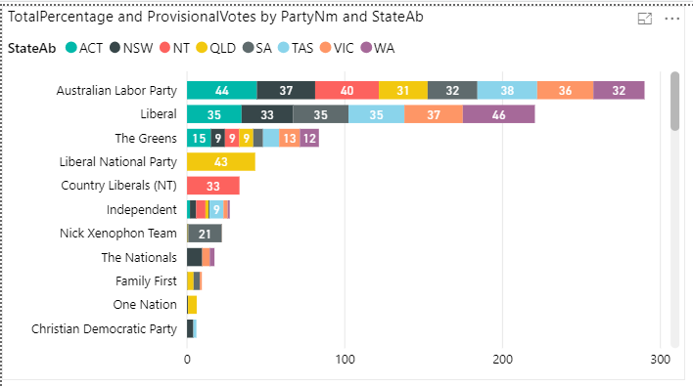

Figure 2Total Percentage and Provisional Votes by Party Name and State

## Chart 2

Figure 3 displays the treemap showing a hierarchical data in rectangles. The data is Ordinary Votes and Total Votes by State. We can observe that the NSW received equal number of Ordinary and Total Votes, whereas Victoria received comparatively lower than NSW of around 3M.

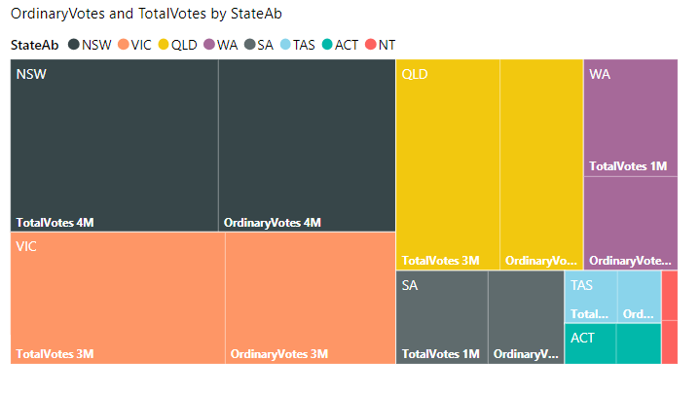

Figure 3 Ordinary Votes and Total Votes by State

## Chart 3 –

The clustered bar chart shows the relationship between the Number of Postal Votes, Absent Votes and Declaration Pre-poll Votes gained by each Party. Postal Votes is a method where ballot papers are distributed to the electors via post ("Postal voting - Wikipedia", 2021). The highest postal votes were for the Liberal, ALP and Liberal National Party. Absent Votes are the votes from someone who are unable to attend the polling station. This was high for both Liberals and ALP, whereas least for the Christian Democratic Party. Lastly, Declaration pre-poll votes are votes in case the name of the electoral is not found on the roll. ALP and Liberal had equal amounts of pre-poll votes, while Christian Democratic Party had the least.

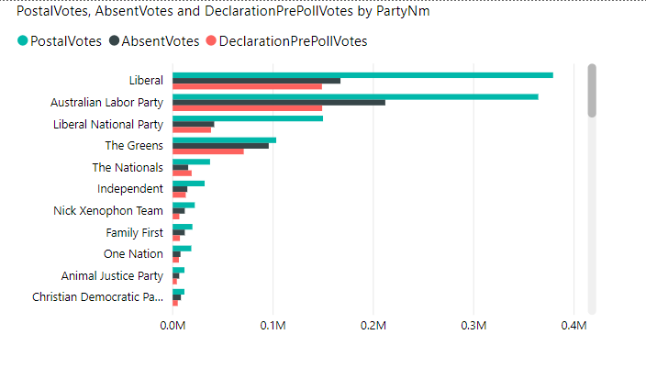

Figure 4 Postal Votes, Absent Votes and Declaration Pre-poll Votes by Party Name.

## Chart 4 -

The below clustered column chart displays the Party Names on the x-axis and the number of elected and nominated candidates on the y-axis. The clustered columns allow for direct comparison of multiple series, i.e., between elected and nominations. It can also show a change over a period. This seems like a reasonable visualisation as Australian Labor Party has the highest number of nominated candidates of around 150, likewise with The Greens being 150 and Independent ranging around 100. For elected candidates, Australian Labor Party has the highest of approximately 55 candidates, followed by The liberals having 48 and Liberal Nationals lower than that.

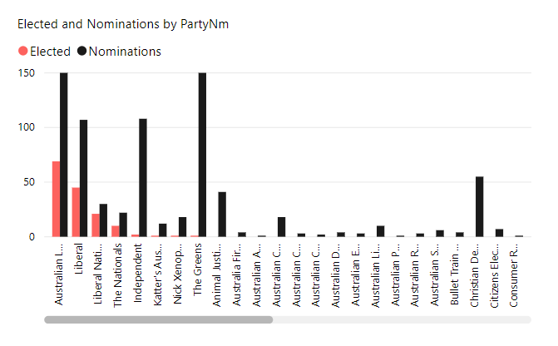

Figure 5 Elected and Nominated candidates by Party Name.

### ***2.2 Dashboard 2: For Political Parties***

Figure 2. shows the dashboard for Political parties. A quick glance of the dashboard shows that there are 5 charts representing the swing rate, polling places, Ordinary Votes casted for Elected candidates and whether the candidates have been previously elected or not. The major Political Parties which are favoured the most include the Australian Labor Party, Liberal and Nick Xenophon team. These parties are seemingly popular which can be observed with the increase in swing rate and the votes castes. Political Parties are majorly concerned about how they have performed as compared to the previous elections. Moreover, they are interested to know where the polling places are held in Australia and This all depends on the number of votes each party has received and the swing rate. Moreover, the charts used are mainly Map, card, table, and stacked column charts.

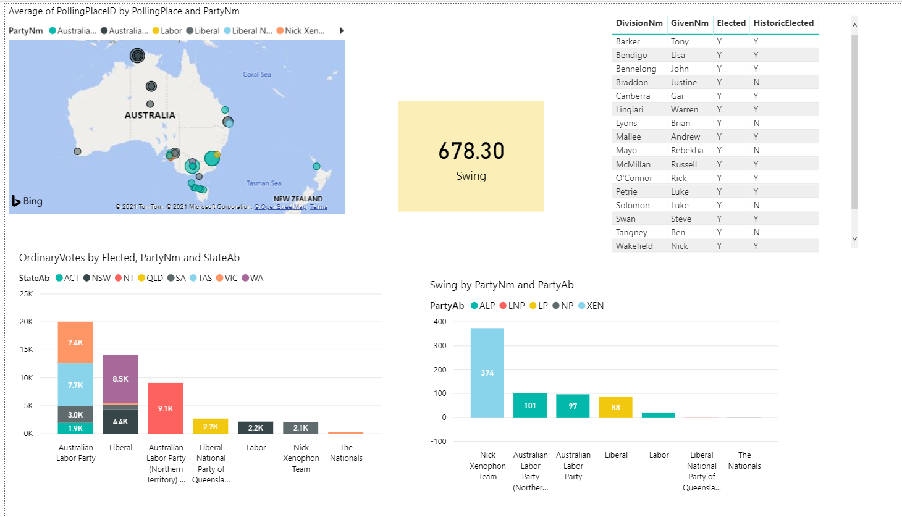

Figure 6 Dashboard for the Political Parties

## Chart 1

The Map demonstrates the following Polling Places along with its respective Polling ID for each Party. We can see how the highlighted bubble spots in NSW, VIS, SA are prominent. Hence, the Power Maps is a geo-spatial data visualisation tool displaying useful locations easily.

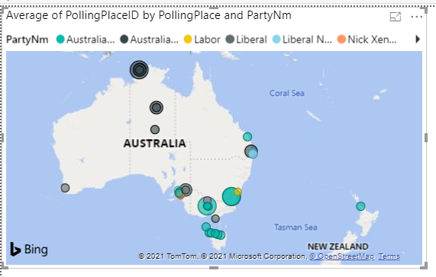

Figure 7 Average of Polling Place ID by Polling Place and Party Name

## Chart 2 –

The table is an important tool which provides information on the Given Candidates name to check whether they have been Historically elected before and currently elected in these general elections. The DivisionNm column also shows the Divisions (i.e., different governing entities) such as Bendigo, Bennelong, etc. This is a comprehensive table having more categorical variables in it.

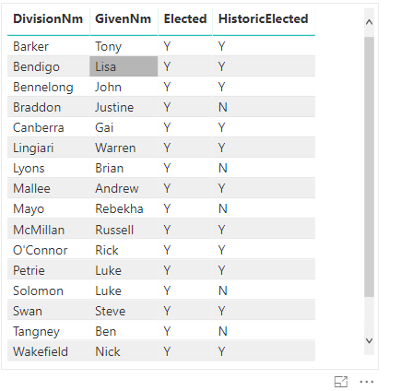

Figure 8 Table showing Division Name, Given Name, Elected and Historically Elected

## Chart 3 –

The card below displays the swing number. refers Swing to the change in voter support from one election to another, expressed in either positive or negative percentage point. This shows a cumulative swing rate of 678.30. If we select any of the above candidates’ name, we can see their respective swing rate below. This is important to determine the level of likelihood that the party / candidate is going to win as there is a change in the voter preference. Thus, in each seat the candidate with the lowest vote is eliminated and then, the preferences are distributing until only the two candidates are remaining going for the winning position.

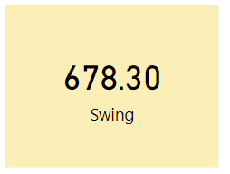

Figure 9 Swing rate

## Chart 4 –

The chart below is a stacked column chart showing the swing percentage on the y-axis and the Party Names on the x-axis. We can observe that Nick Xenophon Team has the highest swing rate of 374 implying that they have been doing better than the previous elections. Whereas The Nationals have a negative swing rate. Australian Labor Party (Northern Territory) has similar swing rate to Liberal Party ranging around 88-101. This evidently shows how Nick Xenophon is gaining more popularity as voters are voting in their side. The coloured bars make it more convenient to read and the figures in the bar displays the swing percentage.

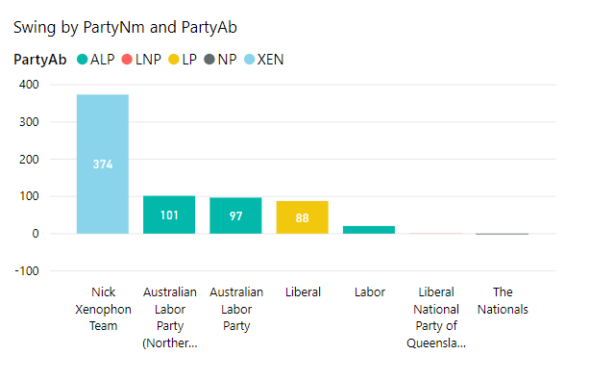

Figure 10 Swing percentage by Party Name and Party Abbreviation

## Chart 5 –

The below column bar chart also has two categorical variables on its x-axis: Party Name and State. On the y-axis is the number of ordinary votes received by each Party. The column charts display data using the rectangular bars where the length of the bar is proportional to the data value (XT et al., 2021). This column chart is oriented vertically. ALP received 7.4k votes in Victoria, Liberal received 8.5k in Western Australia. Whereas The Nationals gained very little number of Ordinary Votes. This is directly proportional to their popularity amongst the public, the economic and public policies they maintain. This is a good representation as it distinctly shows the number of votes on the columns as well.

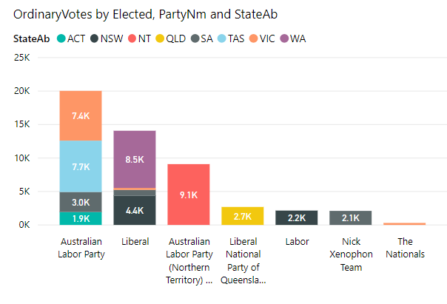

Figure 11 Ordinary Votes by Elected, Party Name and State Abbreviation

### ***2.3 Dashboard 3: For the Public***

The Australian Public concentrates in a more personalised dashboard where the Total Votes gained by each Party stands out. Moreover, they are also concerned about the Voter Enrolment and Ordinary Votes casted to each Premier in the given State. The Public/ Media have increasingly become more interested in the Australian elections due to their pivotal role in shaping the Australian economic landscape. Moreover, they are keen to know the voter turnout of these elections which would ultimately influence the decision-making. These include whether the investments are going primarily towards public development such as transportation, health sector and education. The visualisations included are table, treemap, stacked column chart and column bar chart.

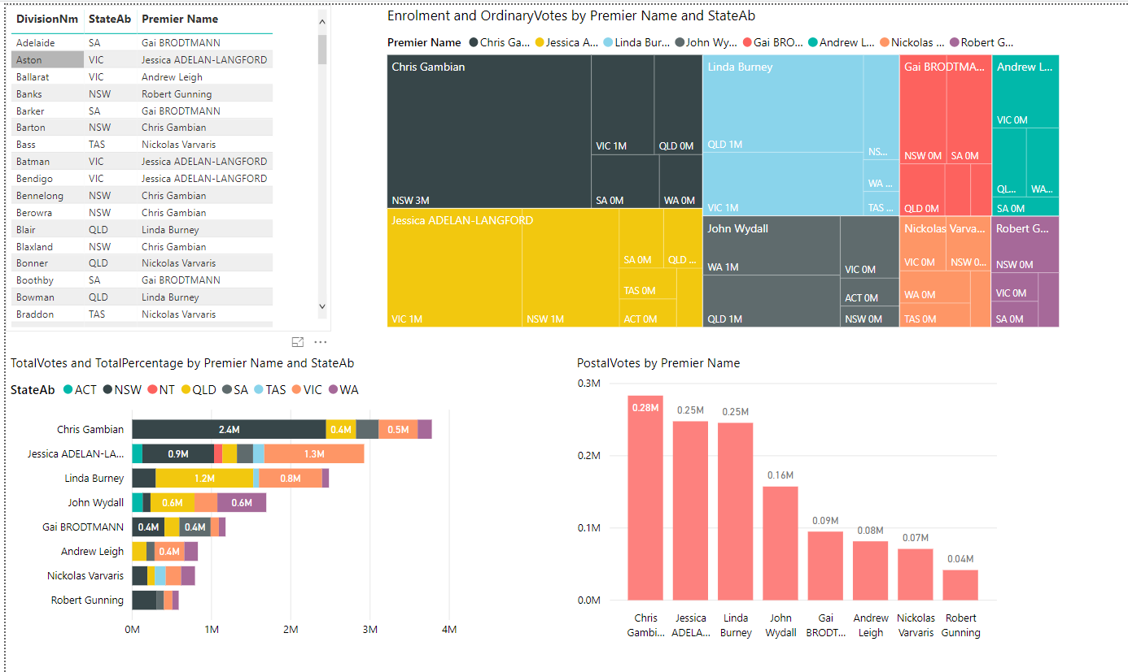

Figure 12 Dashboard for the Public

## Chart 1 –

The table below provides a compiled information on the Premier Name in each State and the respective Division. This grid contains related data in a logical series of rows and columns ("Table visualizations in Power BI reports and dashboards - Power BI", 2021). The benefit of the tables is that you can relate it with many values of a single category. Hence, the Public is eager to know which part of the State the candidates are representing in the elections. We can observe that Gai and Jessica are popular in SA and VIC respectively. Chris Gambian is popular in NSW and Linda Burney in QLD.

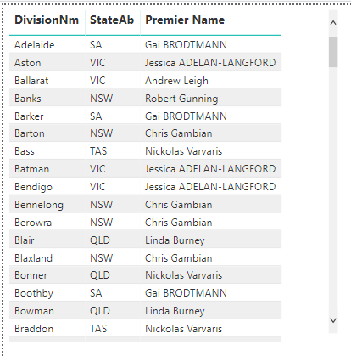

Figure 13 Table displaying Division Name, State Abbreviation and Premier Name

## Chart 2 -

Treemaps are a visual representation of a data tree, where each node is presented as a rectangle, sized, and colored according to values that we assign ("Treemapping - Wikipedia", 2021). Using interactive Treemaps are useful as they legibly display items simultaneously. The colour and size dimensions are correlated in some way with the tree structure, thereby showing some patterns that are difficult to spot. Second benefit would be that tree maps efficiently use space. The below diagram shows the enrolment and ordinary Votes by Premier Name and State Abbreviation. The Voter Enrolment means the voter registration in the Australian elections. We can observe that Chris Gambian in the black color has 3M votes in NSW, 1M in Victoria whereas 0M in QLD, SA, and WA. Followed by Linda Burney who won 1M in QLD and VIC. Whilst the lowest was Robert Gunning losing with 0M votes in NSW, VIC and SA. Gai, John Wydall and Nickolas gained average number of votes.

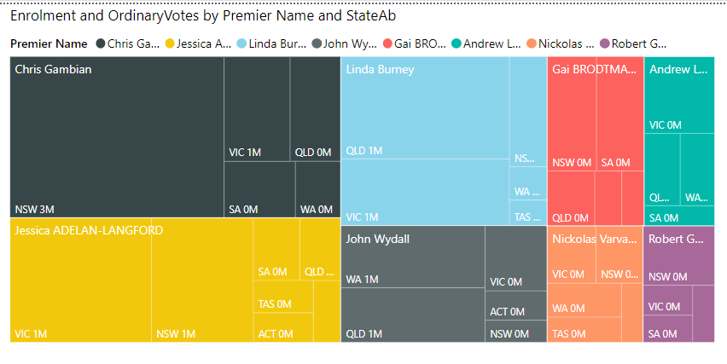

Figure 14 Treemap for Voter Enrolment and Ordinary Votes by Premier Name and State Ab

## Chart 3 -

The stacked bar chart here extends the standard bar chart from looking at numeric values across one categorical variable to two. Each bar in a standard bar chart is segregated into numerous sub-bars stacked end to end, each one corresponding to a level of the second categorical variable. The sub-bars represent the Total Votes gained and the respective Total Percentage by Premier and in each State. We can see that Chris Gambian won 2.4M votes in NSW, 0.4M in QLD. Whereas Jessica won 0.9M in NSW. Nickolas Varvaris and Robert Gunning received least number of votes as compared to the other candidates.

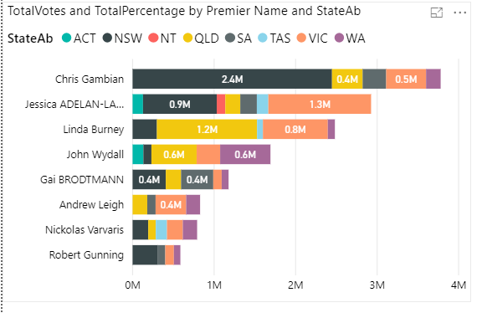

Figure 15 Total Votes and Total Percentage by Premier Name and State Ab

## Chart 4 –

The stacked column chart illustrates the number of Postal Votes casted to each Premier. On the y-axis is the number of Postal Votes and x-axis has the Premier Names. Chris Gambian received the highest votes of 0.28M through post. Followed by 0.25M received by Jessica and Linda Burney. Whereas John Wydall and Gai received average votes. Robert Gunning gained least votes of 0.04M.

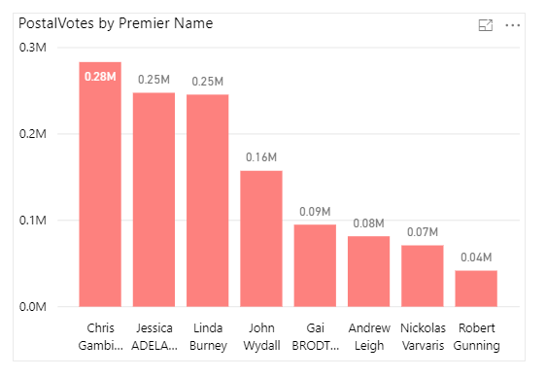

Figure 16 Postal Votes by Premier Name

**3. Recommendations**

The election statistics display the Australian election results. The normal procedure of the election is the counting of majority votes that is casted to a party, and the party leader becomes the next winner of the State/ Federal Elections. In Australia, candidates with comfortable leads would probably fail to win as most of the votes goes via “preference flows” of the voters. However, the key concern here is the stakeholder’s outlook on the dashboard. A fundamental complication to the BI dashboard is:

***To display all the required information on a single screen, clearly and without any distraction in a manner that can be assimilated quickly.***

Thus, the recommendations from the above analysis are:

1. Since AEC is responsible for the maintenance of up-to-date electoral rolls, devising the electorate boundaries and conducting further research for holding safe and sound elections, it is concerned with the percentage and type of votes casted to each party and the State. We can see that conducting ethical, legal and safe elections by looking at the results would better prepare for the next elections. For example, the treemap showing the number of postal votes gained as compared to the declaration pre-poll votes imply that people prefer postal voting system, ensuring safe receival of ballots registered. It would collect more data as to what the most efficient way of conducting the elections is and the dashboard provides statistics on the number of votes counted towards the party. Moreover, the provisional and ordinary votes are maximum towards the Australian Labor Party implying more voter preference. Thereby creating a more filtered and personalised dashboard is beneficial to the AEC.
2. The Political Party dashboard is concerned about the competition between various parties. The dashboard reflects how many seats have been won or lost by each party. Therefore, creating a comparison graphs and charts, whilst also including a gauge for the number of seats would be useful for presenting it to the Political Parties. Additionally, from the column bar graphs we can observe that it provides a more centralised approach to the election settings and the exact percentages of the votes counted, leading to better and accurate results.
3. To encourage people to participate more in voting channels by showing the personalised dashboard and the polling places within their vicinity. Therefore, displaying according to the public’s taste.

There are many instances where elections have gone wrong because of wrong data collection methods and representing the dashboards in an inaccurate way. However, business intelligence analysis has proven to be more useful these days with its interactive and personalised dashboards.

**APPENDIX -**

1. AEC dataset

1. AEC Dataset

1. Political Party dataset

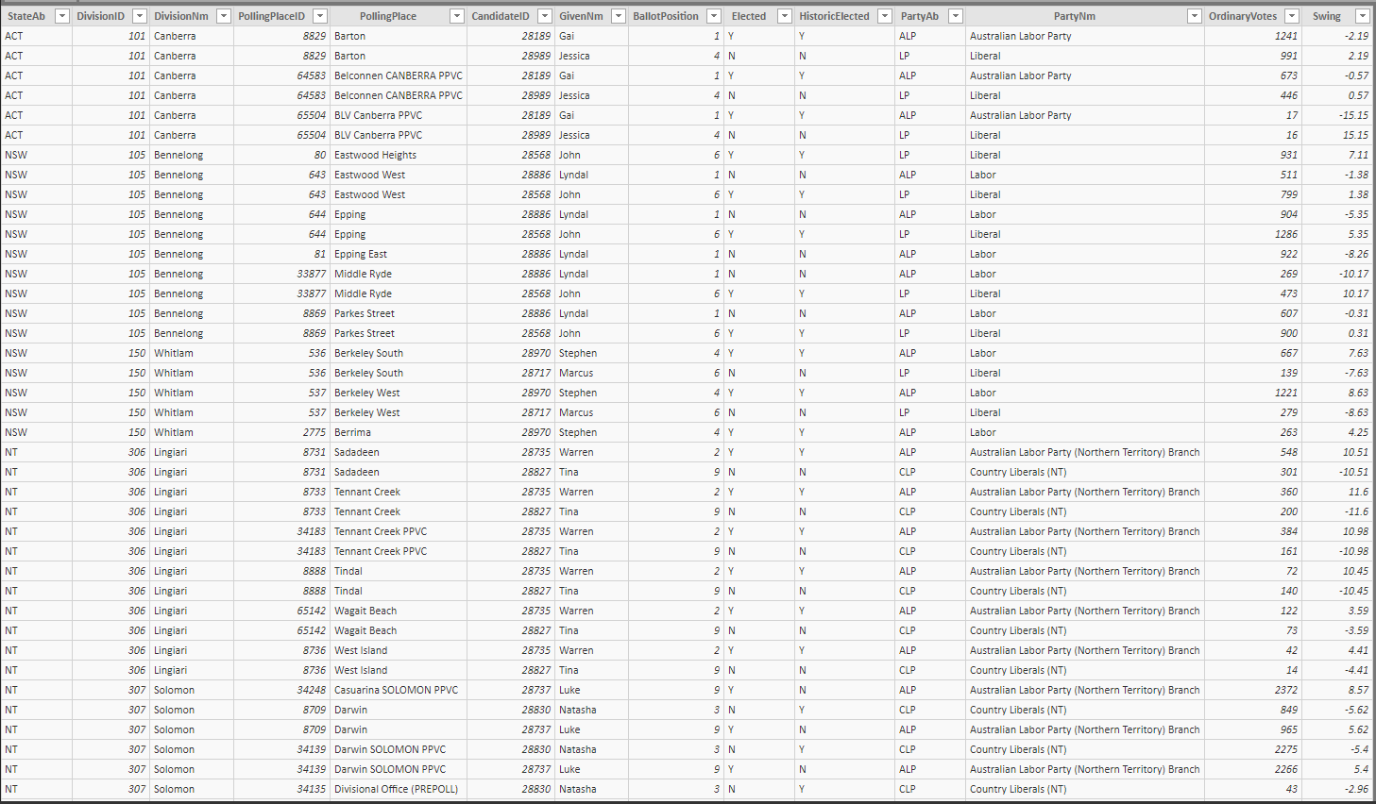

1. Public Dataset

# **4. Reference (APA ref)**

1. A Complete Guide to Stacked Bar Charts. (2021). Retrieved 27 May 2021, from https://chartio.com/learn/charts/stacked-bar-chart-complete-guide/#:~:text=The%20stacked%20bar%20chart%20(aka,of%20the%20second%20categorical%20variable.
2. Clustered Bar Chart | Exceljet. (2021). Retrieved 27 May 2021, from https://exceljet.net/chart-type/clustered-bar-chart
3. Polling place - Wikipedia. (2021). Retrieved 27 May 2021, from https://en.wikipedia.org/wiki/Polling_place
4. Postal voting - Wikipedia. (2021). Retrieved 27 May 2021, from https://en.wikipedia.org/wiki/Postal_voting
5. Swing (Australian politics) - Wikipedia. (2021). Retrieved 27 May 2021, from https://en.wikipedia.org/wiki/Swing_(Australian_politics)#:~:text=The%20term%20swing%20refers%20to,positive%20or%20negative%20percentage%20point.
6. Table visualizations in Power BI reports and dashboards - Power BI. (2021). Retrieved 27 May 2021, from https://docs.microsoft.com/en-us/power-bi/visuals/power-bi-visualization-tables#:~:text=A%20table%20is%20a%20grid,values%20for%20a%20single%20category.
7. Treemapping - Wikipedia. (2021). Retrieved 27 May 2021, from https://en.wikipedia.org/wiki/Treemapping
8. XT, F., Trial, D., Gallery, C., Gallery, T., Gallery, F., & Stories, D. et al. (2021). Choosing the right chart type: Bar charts vs Column charts – FusionBrew. Retrieved 27 May 2021, from https://www.fusioncharts.com/blog/bar-charts-or-column-charts/#:~:text=Both%20the%20Bar%20and%20the,compare%20two%20or%20more%20values.&text=A%20bar%20chart%20is%20oriented,column%20chart%20is%20oriented%20vertically.